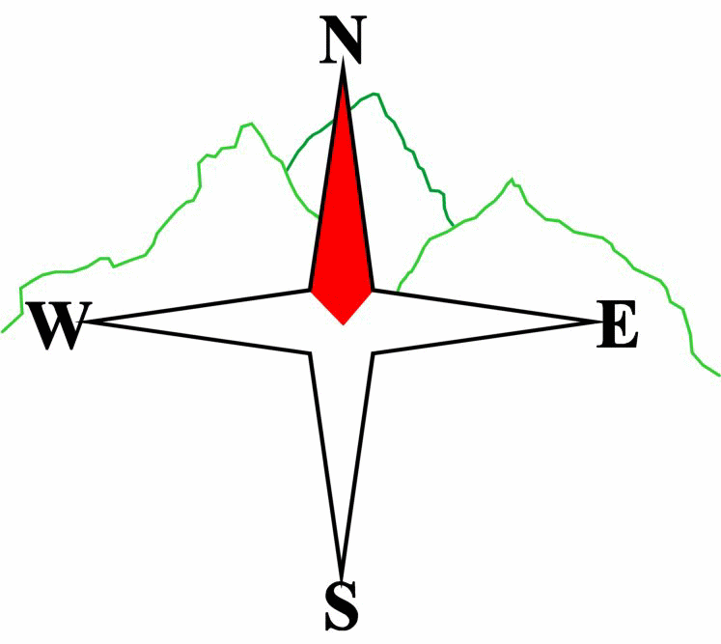***Blairgowrie & District Hillwalking Club***

**www.bdhc.org.uk**

**Fife Coastal Path**

**30/03/2025**

**O.S. Map No**: 59

|  |  |  |  |  |
| --- | --- | --- | --- | --- |
| **Meeting :** | **Blairgowrie** (**Wellmeadow**): **09.00 am** | | **Alyth** (**Square**): **08.45 am** | |
| **times** | **Other: t.b.a.** | | | |
| **Transport:** | **COACH** | | | |
|  | | | | |
| A Walk – Lower Largo to Anstruther | | | | |
| Start in Lower Largo (NO415025) and head E through the village. At Temple Car Park there is the choice of following the FCP (Fife Coastal Path) along the line of the old railway or following the beach. Continue past Dumbarnie Links and SWT Wildlife Reserve and around Shell Bay, skirting the caravan park.  As you approach Kincraig Point there is a choice of ascending to the communications mast or following the route of the Chainwalk. **This latter option is not advised due to high tides forecast at the time of crossing.**  Descend from Kincraig Point to continue along the side of Earlsferry Links and cross the golf course at the marked point to continue along Earlsferry High Street and on to Elie. Head towards the coast past Wood Havern (Ruby Bay) and pass Lady’s Tower before continuing along the FCP (again a choice of through the dunes or by the beach).  Pass Ardross Castle and Newark Castle and on to St Monans church. At this point tides may mean that you have to detour inland and through the village past the Salt Pans and Windmill to Pittenweem.  Again follow the signed FCP through Pittenweem before climbing through the village past Anstruther Golf Course and the Billow Ness to Anstruther. | | | | |
| Approx. distance: 22.5 km | | Total ascent: 70 m | | Min. **walking** time: 5 ½ hrs |
|  | | | | |
| B Walk – Lower Largo to Elie | | | | |
| The route is as described above for the A walk as far as Ruby Bay and Lady’s Tower before returning to Elie where the bus is parked. | | | | |
| Approx. distance: 13.5 km | | Total ascent: 60 m | | Min. **walking** time: 5.0 hrs (@3 kph) |
|  | | | | |
|  | | | | |

N.B. There has been some storm damage to the FCP which may result in minor detours.

These will be advised on the day.

High Tide at 13.32hrs

The next club walk is on the **20/04/2025** to Ben Lomond starting at 07.30 am (Blairgowrie) and 07.15 am (Alyth).

This will be by minibus and cars due to access difficulties.

Template revision: 2024-12-03

**Please note that the Minimum walking times are based on reasonably fast walkers and assuming good conditions. The times do not include stops or breaks.**

## **In poor weather conditions or if members are not comfortable walking at 4km/hour then alternative or shorter routes should be considered.**

|  |  |
| --- | --- |
| IMPORTANT: YOUR SAFETY IN THE HILLS | |
| **The Committee reminds members and guests of the following important points:** | |
| * You are responsible for your own safety * Club officials are not trained mountain leaders * Are you fit enough to complete your chosen walk in the available time? * Know where you are going on the walk and follow the route on your map. * Know how many are in your party and stay together | * Ensure you have enough food plus emergency rations * Carry a map & compass, survival bag, torch, whistle and small first aid kit. Know how to use them. * In winter conditions you must carry an ice axe on high level walks (club rule). You are also recommended to carry crampons. * **Learn** how to use your equipment. |
|
|
|
|
|  |
| **Club officials will be happy to give advice on any of these points if requested.** | |