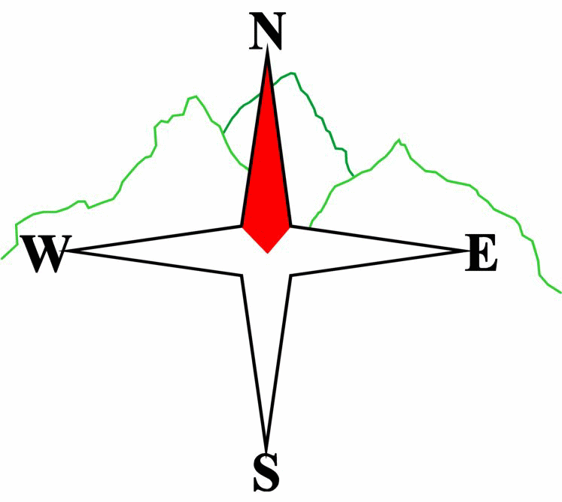***Blairgowrie & District Hillwalking Club***

**www.bdhc.org.uk**

**Cairngorms – Lairig Ghru**

**22/06/2025**

**O.S. Maps No**: **36 & 43**

|  |  |  |  |  |
| --- | --- | --- | --- | --- |
| **Bus times:** | **Blairgowrie** (**Wellmeadow**): **07:00** | | **Alyth** (**Square**): **06:45** | |
|  | **Other: Birnam: 07:20** | | | |
| **C walkers: Blairgowrie (Wellmeadow): 12:00 Alyth Square:11:45** | | | | |
| A and B Walks – Lairig Ghru | | | | |
| Start at Coylumbridge, NH 915 107. Take the lane S past Rothiemurchus Camp & Caravan Park. Continue through the forest for 7.5 km. The route is waymarked at junctions. On leaving the forest the path climbs into the steep-sided gorge of the Lairig until reaching the Pools of Dee after 6 km. Take the path on the E side of the burn for another 5.7 km until reaching the junction for Corrour Bothy. The bothy is c. 500 m on the other side of the Dee which can be a useful shelter if it’s wet. If you do go, on return ensure to take the higher path to continue S then E. On reaching the Luibeg Burn after 4.3 km it may be forded in dry weather or turn N for 350 m to the bridge. Continue E to the bridge over the Derry Burn NW of Derry Lodge (3 km). Good track now 3.6 km eastwards to bridge over Lui Water. Cross and go S until meeting signed path, 065 903, going SW through woods to Linn of Dee carpark and bus. | | | | |
| Approx. distance: 32 km | | Total ascent: 840 m | | Min. **walking** time: 9½ hrs |
|  | | | | |
| C Walk – Clais Fhearnaig circular | | | | |
| Start at Victoria Bridge NS 102 895. Cross onto the grounds of Marr Lodge. Turn first R and continue eastwards through the policies until meeting the public road. Continue on road NE to the bridge at Linn of Quoich. Cross and follow path 300 m NW to the bridge near the Punch Bowl. Cross to the S side of the Quoich Water and follow paths and tracks NW until reaching the Allt Clais Fhearnaig at NO 080 937. Turn left and ascend the path westwards to reach the gorge. Continue SW passed the lochans before descending to meet the track in Glen Lui. Turn L. Take track SSW until meeting bridge over Lui Water. Cross and go S until meeting signed path, 065 903, going SW through woods to Linn of Dee carpark and bus. | | | | |
| Approx. distance: 14 km | | Total ascent: 345 m | | Min. **walking** time: 5 ¼ hrs (@ 3 kph) |
|  | |  | |  |

**Please note that the Minimum walking times are based on reasonably fast walkers and assuming good conditions. The times do not include stops or breaks.**

## **In poor weather conditions or if members are not comfortable walking at 4km/hour then alternative or shorter routes should be considered.**

The next club walk is on the **13/07/2025** to **Ben More** starting at 07:30 (Blairgowrie) and 07:15 (Alyth).

Other information/events: Special train walk **Rannoch Station to Kingshouse on Sat 2th August** and **BBQ on Sat 9th August at Roddy’s.**

|  |  |
| --- | --- |
| IMPORTANT: YOUR SAFETY IN THE HILLS | |
| **The Committee reminds members and guests of the following important points:** | |
| * You are responsible for your own safety * Club officials are not trained mountain leaders * Are you fit enough to complete your chosen walk in the available time? * Know where you are going on the walk and follow the route on your map. * Know how many are in your party and stay together | * Ensure you have enough food plus emergency rations * Carry a map & compass, survival bag, torch, whistle and small first aid kit. Know how to use them. * In winter conditions you must carry an ice axe on high level walks (club rule). You are also recommended to carry crampons. * **Learn** how to use your equipment. |
|
|
|
|
|  |
| **Club officials will be happy to give advice on any of these points if requested.** | |