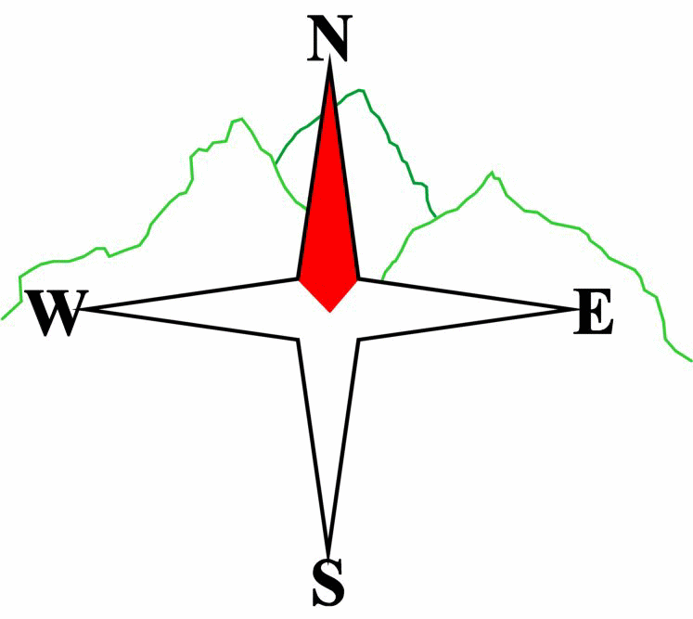
Blairgowrie & District Hillwalking Club

www.bdhc.org.uk
The Mounth

02/06/2024
O.S. Map No: 43 & 44

Bus times: | Blairgowrie (Wellmeadow): 07:30 am |  | Alyth (Square): 07:45 am
 | Other: C Walk pick up Wellmeadow 10:30 am

A & B Walk – Jock’s Road (South to North)
Start at Braedownie quarry NO 289 757. Follow the road, then track, past carpark and Acharn into the forest. If the path is still blocked by fallen trees at 269 760, follow the diversion on the south side of the White Water. After regaining the original path follow it up over the high ground and down to Loch Callater and Loch Callater Lodge. There is a good track thereafter to Auchallater.
Approx. distance: 22 km |  | Total ascent: 800 m | Min. walking time: 7 hrs

C Walk – Glen Clunie to Glen Callater over the Bealach Buidhe
Start at parking area approx 500m N of Baddoch road-end NO 141 835. Take path on S side of burn Eastwards up into the corrie. Higher up, this becomes very indistinct but keep heading slightly N of East to the bealach. Cross the track and follow the burn down to Lochcallater Lodge. The path is difficult to find but there is a footbridge over the burn near the bottom. From the Lodge, proceed as A walk on the track NW to Auchallater.

Approx. distance: 10 km |  | Total ascent: 260 m | Min. walking time: 4 hrs (@3 kph)
The next club walk is on the TBA to TBA starting at TBA am (Blairgowrie) and TBA am (Alyth).
Other information/events: Autumn Weekend Kelso TBC

Please note that the Minimum walking times are based on reasonably fast walkers and assuming good conditions. The times do not include stops or breaks.

In poor weather conditions or if members are not comfortable walking at 4km/hour then alternative or shorter routes should be considered.

IMPORTANT: YOUR SAFETY IN THE HILLS
The Committee reminds members and guests of the following important points:
- You are responsible for your own safety  - Club officials are not trained mountain leaders  - Are you fit enough to complete your chosen walk in the available time?  - Know where you are going on the walk and follow the route on your map.  - Know how many are in your party and stay together | - Ensure you have enough food plus emergency rations  - Carry a map & compass, survival bag, torch, whistle and small first aid kit. Know how to use them.  - In winter conditions you must carry an ice axe on high level walks (club rule). You are also recommended to carry crampons.  - Learn how to use your equipment.
Club officials will be happy to give advice on any of these points if requested.

